ATM Machine

**Introduction:**

The project is titled as **ATM Machine** and developed using Python language. The Automated Teller Machine (ATM) allows bank customers to access their accounts without visiting the bank. When a user needs to withdraw cash, they can enter their PIN number (personal identification number) and the amount to be withdrawn will be displayed. Once their withdrawn was successful, the amount will be debited in their account and also they can choose to display how much amount is in the account.

**Features:**

* Transfer funds between linked bank accounts
* Easier Access
* Low Cost
* Prints recent transactions list
* Change your pin
* Prepaid mobile recharge
* Bill payments
* Perform a range of features in your foreign language.

**4W's & 1H**

| **Sl.No** | **Questions** | **Description** |
| --- | --- | --- |
| 1. | What | It's an automatic machine to check Balance, withdraw or Deposit the money. |
| 2. | Who | Anyone with an ATM card can use the machine. |
| 3. | When | It is available 24X7, 365 days. |
| 4. | Where | It is available in various places.. |
| 5. | How | The program of this application was developed in Python language to avoid the complexity and to keep it simple. |

## SWOT Analysis:

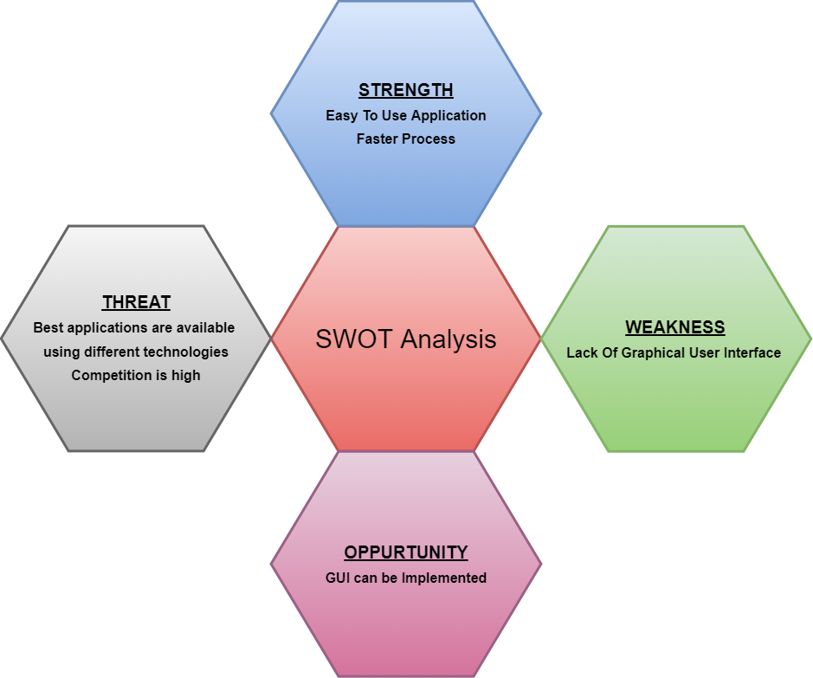

**Flow Chart:** 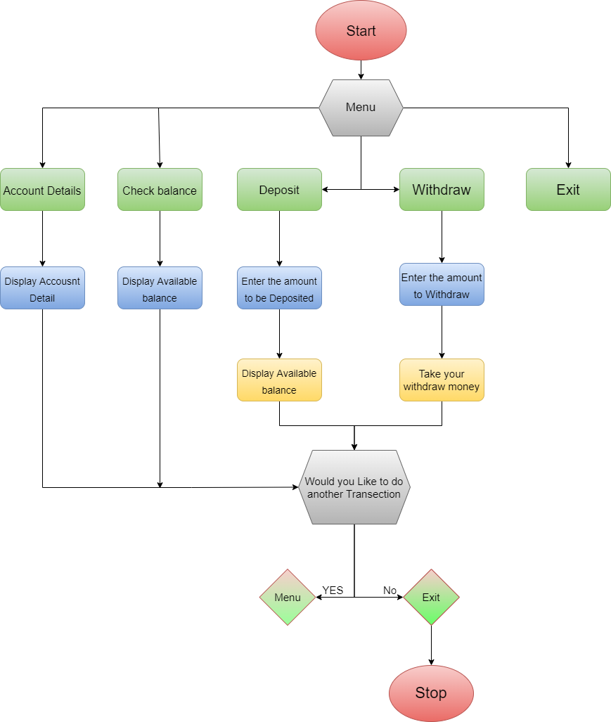

**Advantages:**

* Easy and faster access
* Automated teller machines are easily arranged in different areas so that every bank customer can visit the machine to execute any transaction.
* It is used to withdraw the money in a fraction of minutes so that time can be saved.
* It reduces the cash-carrying because anyone can withdraw the money at any ATM center so it works like a cash point
* The ATM provides 24 hours service
* The ATM provides privacy in banking communications
* The ATMs reduce the workload banks staff
* The ATMs are convenient for banks customers
* The ATM is very beneficial for travelers

**Disadvantages:**

* IT charges some amount once free transactions exceed
* Once ATM card damages then cash withdraw is not possible
* Possibility of cash robbery from ATMs
* ATM pin can be easily hacked by criminals by operating an ATM
* The risk of theft is high while going to ATMs

**High Level Requirements:**

| **ID** | **Description** | **Status** |
| --- | --- | --- |
| HR01 | Menu | Implemented |
| HR02 | Account Detail | Implemented |
| HR03 | Check Balance | Implemented |
| HR04 | Deposit Cash | Implemented |
| HR05 | Withdraw Cash | Implemented |

**Low Level Requirements:**

| **ID** | **Description** | **HR ID** | **Status** |
| --- | --- | --- | --- |
| LR01 | Main menu should consist 5 options: 1. Account Detail 2. Check Balance 3. Deposit Cash 4. Withdraw Cash 5. Exit | HR01 | Implemented |
| LR02 | Reading user input to select particular option | HR01 | Implemented |
| LR03 | Output screen will display the overall Account Details | HR02 | Implemented |
| LR04 | Should display final updated balance after credit or debit | HR02 | Implemented |
| LR05 | Output screen will display the overall balance | HR03 | Implemented |
| LR05 | Read user input to Deposit the exact amount of cash | HR04 | Implemented |
| LR06 | Read user input to withdraw entered amount exactly | HR05 | Implemented |
|  |  |  |  |